**Passive Buzzer singing "Happy Birthday"**

**1. Learning Target**

In this course, we mainly learn to use STM32F103RCT6 drive passive buzzer to sing "Happy Birthday".

**2.**[**Preparation before Class**](E:/Dict/9.2.0.0/resultui/html/index.html#/javascript:;)

The hardware needed is STM32F103RCT6 development board, passive buzzer module, Dupont line.

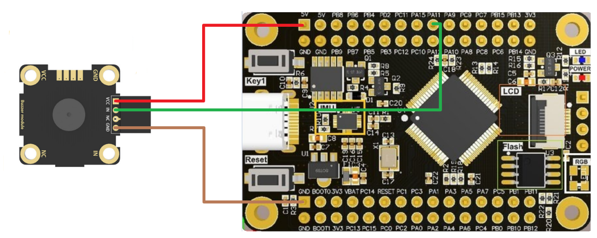

|  |  |
| --- | --- |
| passive buzzer module | STM32F103RCT6 |
| VCC | 3.3V |
| GND | GND |
| IN | PA11 |

**3.**[**code snippet**](E:/Dict/10.0.3.0/resultui/html/index.html#/javascript:;)

Initializes the buzzer pin

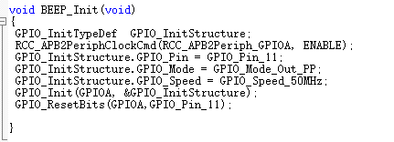

The song is represented by two arrays, one is the pitch and one is the duration of the pitch.

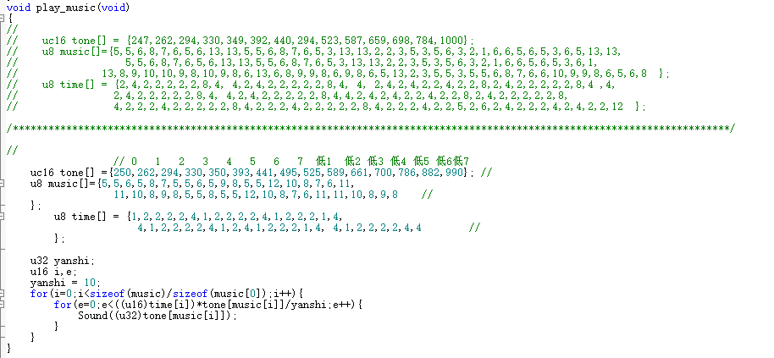

**4.Experimental Phenomenon**

After the program download completed, the single chip connected to the electricity, we can hear the buzzer "sing" Happy birthday song.